Proportional Controller value Calculation (pixel displacement -> Velocity)
- Input is the physical pixel displacement
- Output is the physical velocity (degrees per second for yaw and metres per second for climb and decent values)

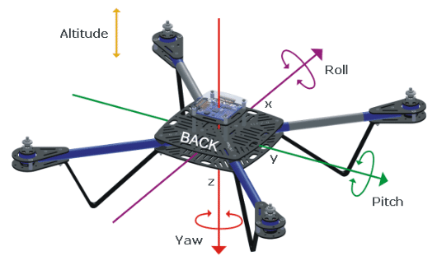

Basic equation:

Firstly, to calculate , the maximum horizontal pixel displacement must be found.

OpenCV resolution of (, )

There for maximum horizontal pixel displacement is 320px
Steady turning is around 30 degrees per second.

For Kp, alt
Max vertical displacement is 240px and a gentle descent or climb speed is 0.5ms-1.

In real-time robotics, gain calculation is paired with two mathematical safeguards to keep the flight stable:
- Saturation Clamping: Never let the calculated output exceed your physical limit, even if an unexpected frame glitch occurs:

- Deadband: Prevent high-frequency motor jitter by ignoring small errors near the center (e.g., within ):

For the same reason

Example of this being applied in code
